

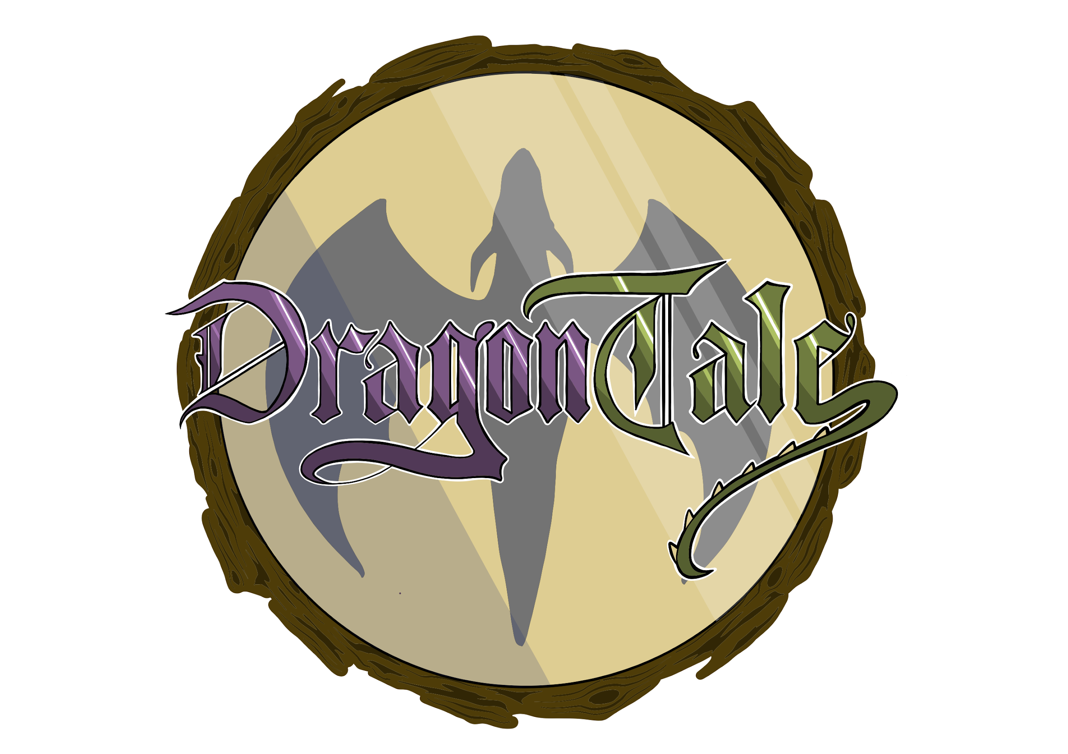

**Dragon Tale**

**Game Design Document**

Desenvolvimento de Jogos de Computador

MIEIC - 2017/2018

Group 5:

Andreia Rodrigues - up201404691 - [up201404691@fe.up.pt](mailto:up201404691@fe.up.pt)

Eduardo Leite - gei12068 - [gei12068@fe.up.pt](mailto:gei12068@fe.up.pt)

Francisco Queirós - up201404326 - [up201404326@fe.up.pt](mailto:up201404326@fe.up.pt)

Ka Chon Ho - up201711244 - [up201711244@fe.up.pt](mailto:up201711244@fe.up.pt)

**Index**

**Game Overview** **3**

Game Concept 3

Genre 3

Target Audience 3

**Target Rating** **3**

**Unique Selling Proposition (USP)** **3**

Inspiration 3

**Competitive Analysis** **4**

**Characters** **5**

Main Characters 5

Dragon 5

Princess 5

Prince 6

Secondary Characters 7

Mage 7

**Story** **8**

**Features** **9**

General Features 9

Gameplay 9

World Overview 9

Forest 9

Village 10

Castle 10

World Entities 10

Skills Progression 12

Combat 13

Artificial Intelligence 13

Game Controls 13

Game Progress 14

Camera 15

Saving 15

**User Interface** **16**

**Concept Art** **23**

**Sound** **25**

**Technologies** **25**

**Video** **25**

# **Game Overview**

## **Game Concept**

DragonTale is a 3D role-playing/adventure fantasy game with a unique narrative and gameplay that will challenge the player’s ability to navigate in an open world full of surprises and test his battlling skills.

In this single player game the player will control the main character, a little dragon with the bravery of a knight that will fight the enemies crossing his path, making him stronger enough to defeat the final boss, the evil prince, and save the princess.

## Genre

The genre we've chosen for the game is role-playing/adventure fantasy.

## **Target Audience**

Despite the simple and cartoony appearance, we will target all audiences, as long as they enjoy RPG adventure games.

# Target Rating

The game will feature mild violence which should allow the game to be rated PEGI 7 and ESRB E or E10+.

# Unique Selling Proposition (USP)

Our element distinguishes itself by the non-conventional storyline where we have a dragon as the main character that has to fight a prince. Our uniqueness is built around the artwork, which is based in a rather simplistic style. We used exaggerated anatomy to aid a visual perception of each and every character at first glance. The colors are slightly desaturated and not too luminous, focusing on a fantasy and earthy feel, giving off a medieval yet magical aesthetic.

## Inspiration

When thinking about how the game we used several games. The Final Fantasy franchise is a classical example of a story-driven turn-based RPG game. From these we took the fantasy and usually medieval-esque environment. From the Pokémon franchise games we took the feel of the arrangement of objects in the battle scene. Overall the examples were used very loosely and during the development, we have not tried to strongly replicate any of these games, taking our own liberties on what worked and looked well.

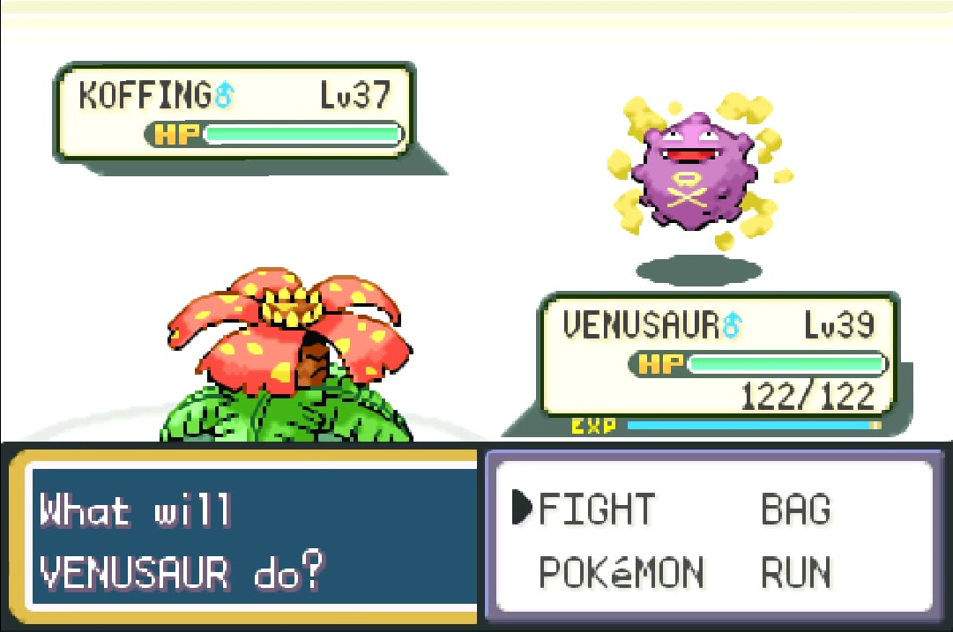

Image 1 - Battle Interface from the Pokémon games.

# 

# Competitive Analysis

To perform competitive analysis we first must mention similar products, namely similar RPGs. The most similar family of games is the Final Fantasy franchise. Very similar battle mechanics, world navigation and also using a story-driven approach.

Our game has some differences:

* The art style we'll employ will have a more cartoonish approach compared to those games. This will appeal to some players and make us visually distinguishable.
* Despite sharing the world navigation mechanic, in our game the enemies exist physically in the world, requiring physical collision in order to begin the battle sequence, whereas in the Final Fantasy franchise these are random triggers without any cause, which can be frustrating and unexpected.
* In Final Fantasy games the protagonists are for the most part very close to humans. In our game will give an unusual opportunity to play as a more distinct character, a dragon.

# Characters

## Main Characters

### Dragon

The dragon character is the main character and is going to be controlled by the player. It is the child of the two dragons that were previously keeping the princess safe from danger, giving their life to protect her when the prince found where they were hiding. The little dragon is not aware of this so he goes exploring the world when his parents don’t return home. He finds clues along the way that allow him to understand the cruel reality of what happened to them.

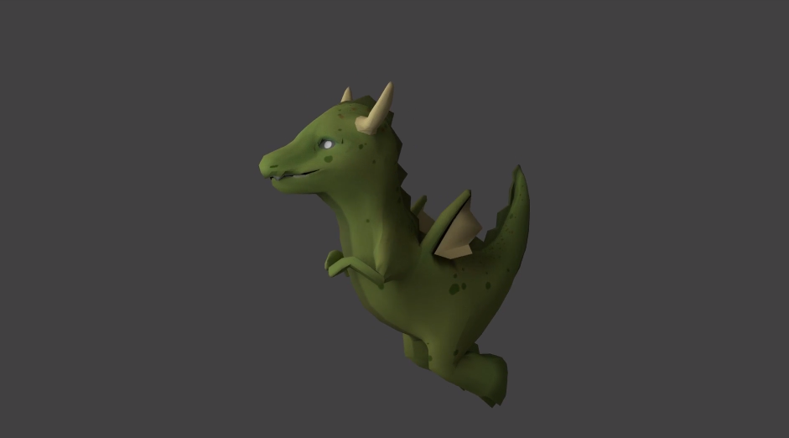

Image 2 -Dragon 3D model.

### Princess

The princess character is the "goal" of the game. The player is not aware of it at first but while playing he will understand that he must save her from the evil prince. She is the only daughter of the rich family that rules the kingdom. She was previously protected by two very powerful dragons that failed their mission when the evil prince came to where she was hiding and were defeated.

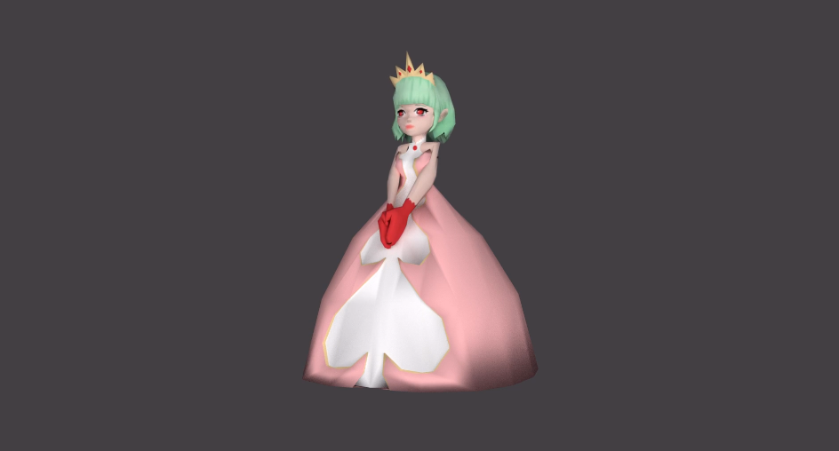

Image 3 - Princess 3D model.

### Prince

The prince character is the antagonist of the game. The prince wants to marry the princess by any means to get to her family’s money and he defeated the little dragon’s parents to get to her. Now, he is keeping her prisoner on the top of the castle. The player must defeat this character in order to save the princess.

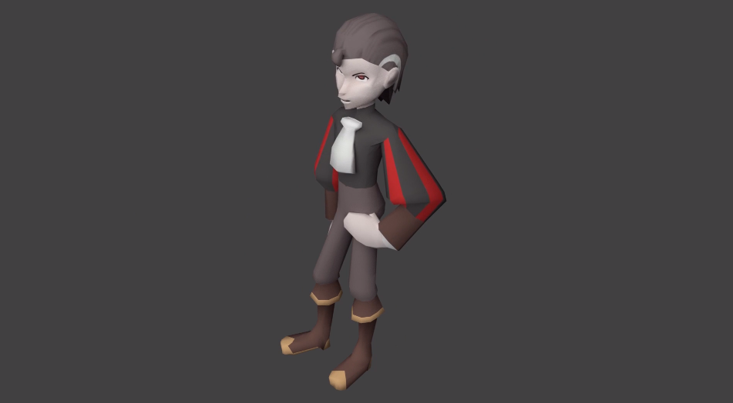

Image 4 - Prince 3D model.

## Secondary Characters

### Mage

The mage characters are the prince's minions. They are meant to not let anyone go to the prince’s castle and defeat whoever crosses their path. They are the most common enemy in the game.

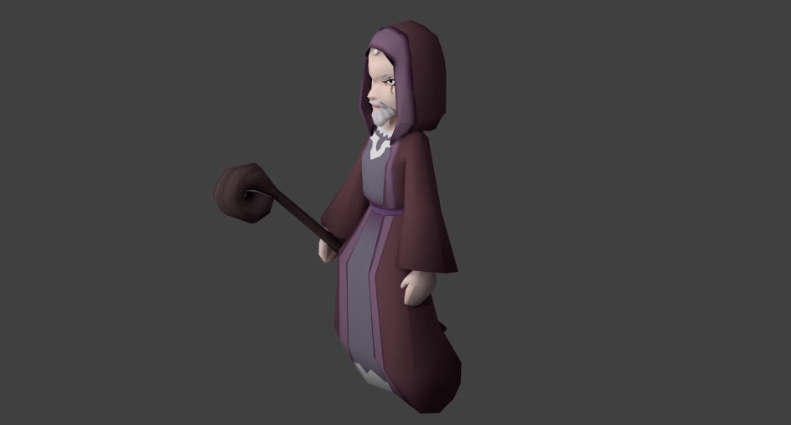

Image 5 - Mage 3D model.

# Story

Once upon a time in an ancient kingdom, there was a princess who lived happily in her prospering kingdom.

She was guarded by their friends, two mighty dragons and their little kid.

But everything changed when an evil and greedy prince from another kingdom, seeking to save himself from bankruptcy, decided to force the princess to marry him.

Seeing this, the dragon guardians promised to welcome and protect the princess in their cave.

However the prince found the cave, taking the princess to his tower and slaying the parents of our little dragon.

Not knowing what had happened, the little dragon goes on an adventure to find his family.

He starts to find small clues about what happened and understands his parents were killed protecting the princess.

And so, he made it his mission to save the princess and slay the evil prince, fighting the prince’s minions that cross his path and getting stronger with every defeated foe.

# 

# F**eatures**

## General Features

The game is a single player game with 3D graphics. There is an open world scenario with well defined paths in which the player can navigate and interact with items and NPCs to discover new pieces of the story or to start new battles as well as a battle scenario. The UI is simplistic and easy to use.

There are 2 stats in the game, health and attack, which vary with the level and experience the player has.

In the battles, the player has access to 5 different skills: Fire Attack, Heal, Block, Tail Attack and Slash which serve different purposes against different types of enemies.

We initially planned to have 3 different sceneries in the game which allow the player to get new skills along the way and for the little dragon to evolve overtime and get stronger and better skills, but due to time constraints we made less sceneries and scrapped the idea of progressively getting the skills.

## Gameplay

### World Overview

We initially thought, for the game process, to develop three zones, the Forest, the Village and the Castle. But due to how ambitious that would be in the time period that was given, we've only developed the forest level and a battle scene for the castle.

The objective is for the protagonist to progress through the different zones, taking down enemies and getting stronger enough to be able to reach and defeat the final enemy.

#### Forest

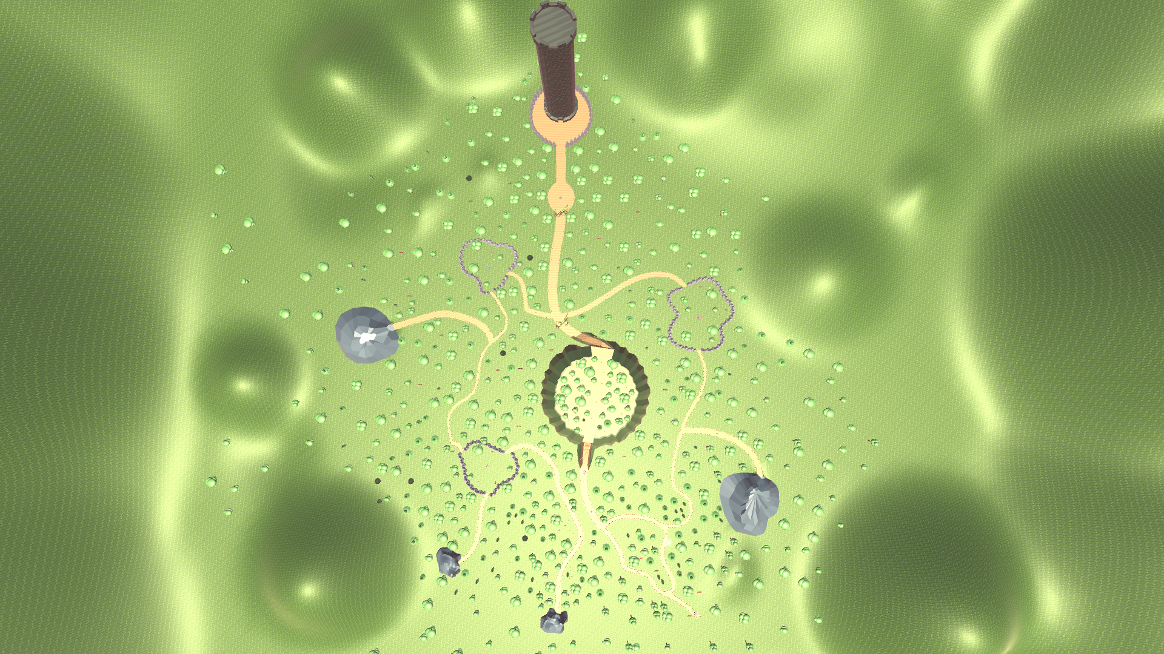

Image 6 - Aerial view of the Forest scene.

In the forest level the player has his first contact with the world, items and NPCs. While collecting the different items he will have access to the backstory of the game and understand the motivations of the little dragon to fight the mages, as well as the main objective of the game: to find the prince and defeat him to save the princess.

#### Village

This was supposed to be a intermediate level that would connect the Forest to the Castle, representing the suburbs of the castle. The level wasn't developed due to the reasons raised in the World Overview section.

#### Castle

The castle is the final level, where the little dragon will progress in order to meet the final boss, the evil prince.

### World Entities

The world contains several types of elements. To start off, there are the decoration items like trees, caves, etc. One type are the vines. They block the path to the end boss earlier in the game. After the player proceeds further into the game, these vines disappear, unlocking the path to the end of the game. There are also many functional items. The scrolls are used as a way to tell the story to the player. When the player reaches the scroll, a user interface element shows up that tells a piece of the story. The enemies, when touching them, trigger a battle sequence that, in return, give experience to the player character to make them strong enough to progress in the game. The fountains are a way for the player character to heal and also for the player to save the progress in the game.

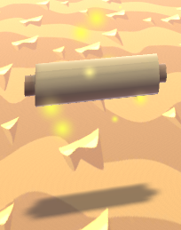

Image 7 - Scroll.

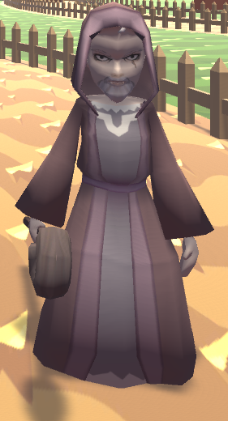

Image 8 - Enemy / Mage.

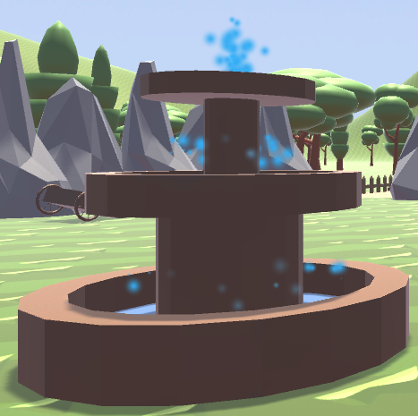

Image 9 - Fountain.

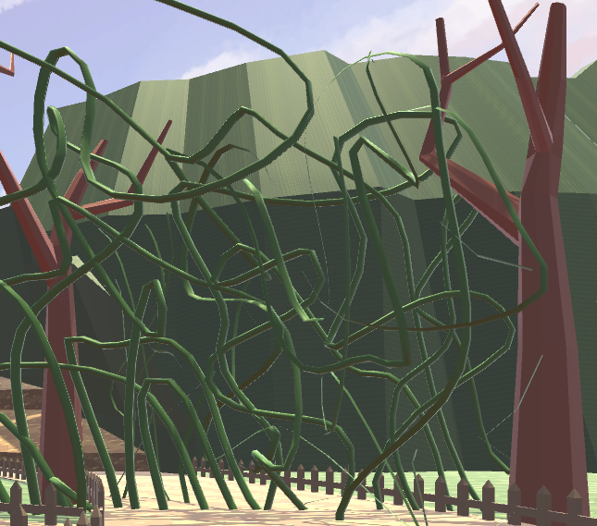

Image 10 - Vines.

### Skills Progression

In the concept, it was defined that the dragon would have different levels of progression, not having access to all skills in the first place and getting each of them as a rewards for the progress made in the game, as well as evolving the dragon’s model to show this exact progression, making him look stronger overtime.

In the prototype developed, for a more simplistic approach and due to restrictions of time, this progression was made in a simpler way. The player has all the skills available in the forest level and the model is not changed overtime. This way the player can experience the different skills without restrictions and the progression of the player is reflected on the level and experience gained from winning battles against the NPCs.

### Combat

The game features a turn-based combat system. The player takes a turn to select from one of the abilities and then the enemy units have their turn.

Initially, the group thought of 3 different types of enemies: mage, swordsman and spearman. But only the mage was developed. To compensate for the lack of enemy types, the mage has 3 different subtypes: fire, heal and stun mage.

The fire mage always cast a fireball, a damaging spell.

The heal mage, every second turn, if there's a wounded enemy, that enemy is healed. Otherwise, they also use a fireball.

The stun mage, every third turn, a stun spell is used on the player. If the player doesn't block this ability, the player gets stunned, not having their next turn. In other turns, the stun mage uses fireballs.

This model makes every skill mentioned before relevant using the following logic:

Fireball, has a 2 turn cooldown and is the highest damage skill.

Tail Attack, has a 1 turn cooldown and is the second highest damage skill.

Slash, has the lowest amount of damage but has no cooldown. It’s used to finish off low hp enemies or to sustain the damage when the other skills are on cooldown.

Heal, even though it does not compensate to heal in most situations, when facing a single healing mage that is going to heal in the next turn but not enough to not be finished off in the next round it does pay off to heal, realizing this hidden advantage is crucial to beat the game with maximum efficiency (not getting the experience from the secondary paths)

Block, blocking is always the best option when the enemy mage stunners are going to move, but it’s also a clever way to wait for the cooldown of the best damaging abilities. This mechanic adds complexity to the game because depending on the situation it may be better to block than to Slash.

### Artificial Intelligence

For artificial intelligence, the game features it in the combat decisions for the enemies. The AI takes into account cooldown time of their own abilities like the cooldown for stun on stun type enemies and the cooldown for heal on heal type enemies. The heal type enemies also don't heal if there isn't anyone wounded, avoiding wasting a turn and triggering the cooldown for the ability.

## Game Controls

The controls for the movement on the world are made with the WASD keys. The Space tab is used for jumping if pressed once and for double jumping if pressed twice. If in the second press the Space tab is not released, the dragon will fly, falling slowly until it touches the ground.

In the battle scene the control of the skills to use and the enemies to attack is made with the arrow keys. The up and down arrows are used to choose the desired skill when the dragon gets its turn. The enter key determines that the selected skill is the one to use. When the skill is chosen, the left and right arrow keys are used to select the enemy to attack. The enter key determines that the enemy selected is going to be attacked.

In the world scene, at any time, the player has the ability to pause the game by pressing the escape key.

## Game Progress

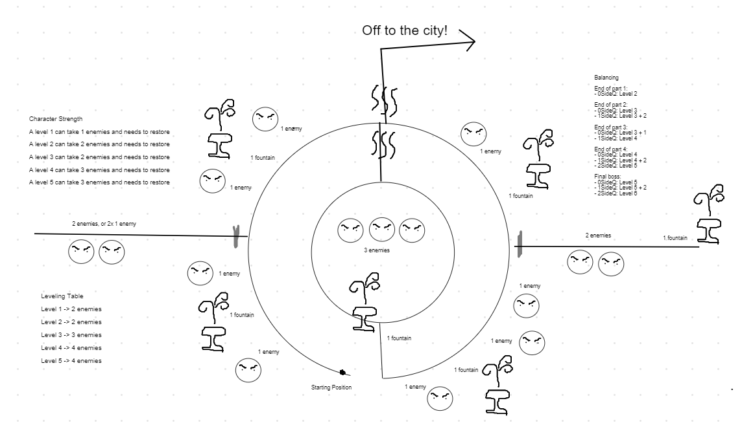

Image 11 - Early map and balancing draft.

The player gains experience after every battle won, leveling the player up after reaching defined milestones. Every time the player levels up he gets enhanced values to his maximum health and attack and fully restores his health points.

In the upper left corner of the draft we have planned how many enemies the dragon must be able to defeat at each given level.

In the lower left corner we plan the amount of enemies the dragon must defeat to level up.

In the upper right corner we see what level the dragon will reach in the end each of the 4 quadrants and at what level he will face the prince. Some entries have multiple values that depend on how many side paths the player has explored.

Our design ensures that the player will be at least level 5 when he faces the prince by following only the main path and will be at most level 6 by defeating every enemy available in the game before going for the final battle. By doing so, we let experienced players to do speed runs where they need to make clever decisions because the margin for error at level 5 is very very small and let casual exploring players have more margin for error facing the enemy at level 6.

The progression is also controlled by the vines we see in the map, that only enable access to the final battle upon facing the enemies on the hill, by fountains placed in key points for the player to save and restore his health (some redundancy exists in the fountains to allow the player to be able to progress regardless of how many side quests he does) and by scrolls that will show new pieces of the story along the way.

## Camera

In the world view, the camera can be controlled with horizontal mouse movement in order to move the camera around the player. This is very convenient for the player as they can use whatever angle is comfortable and allows to watch the scenery in the game. In this view, the player can also zoom the camera in and out.

In the battle view, the camera is fixed, but placed in a way that focuses on the battle itself, which is the relevant element in the scene.

## Saving

As mentioned before, the player can save the game by colliding with a fountain, this feature was one of the hardest to implement because of the amount of information needed to persist.

Because the world and the combat take place in different scenes, we also have to take into consideration the persistence between these two contexts.

Because every fountain, scroll and enemy can only be used/caught/fought once and the vines can be enabled or disabled, all this information needs to be stored in memory and in the save files, as well as the position, experience, health and level.

After loading the world scene, regardless of the origin (battle scene or main menu) the game objects are destroyed if they are no longer available, to prevent the player from instantly colliding with an enemy upon world loading (before the destroying routine), some information about the last entity fought is also persisted.

Another difficulty is that when a player loses, we have to start at the last fountain saved, which accentuated the need to distinguish the in memory persistence from the file persistence.

The file persistence is platform independent because it uses a special string that maps to usual storage locations (appdata for pc for example), and it’s achieve using serializable classes and binary formatters.

# 

# User Interface

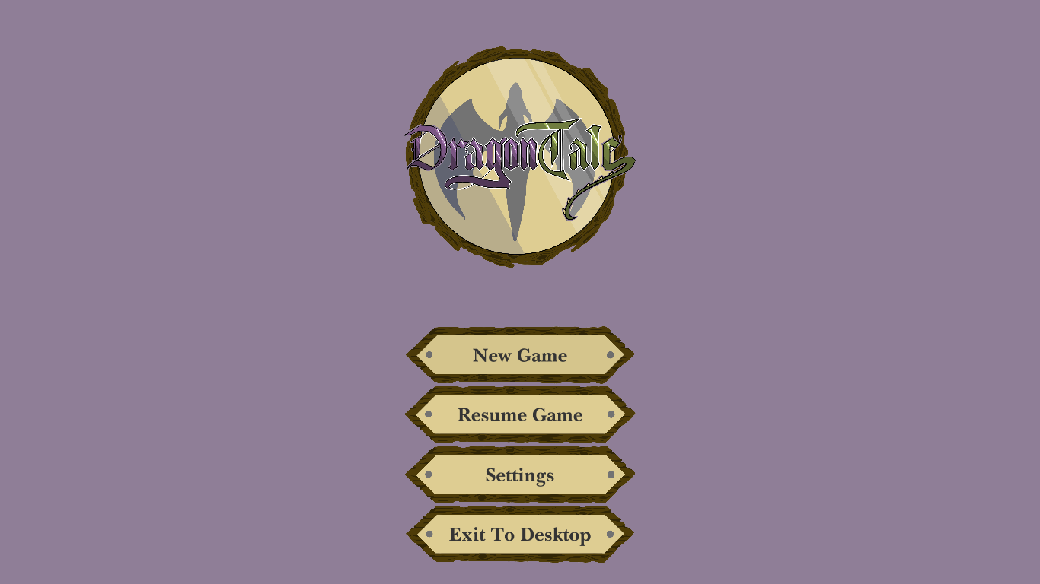

Image 12 - Main Menu Screen.

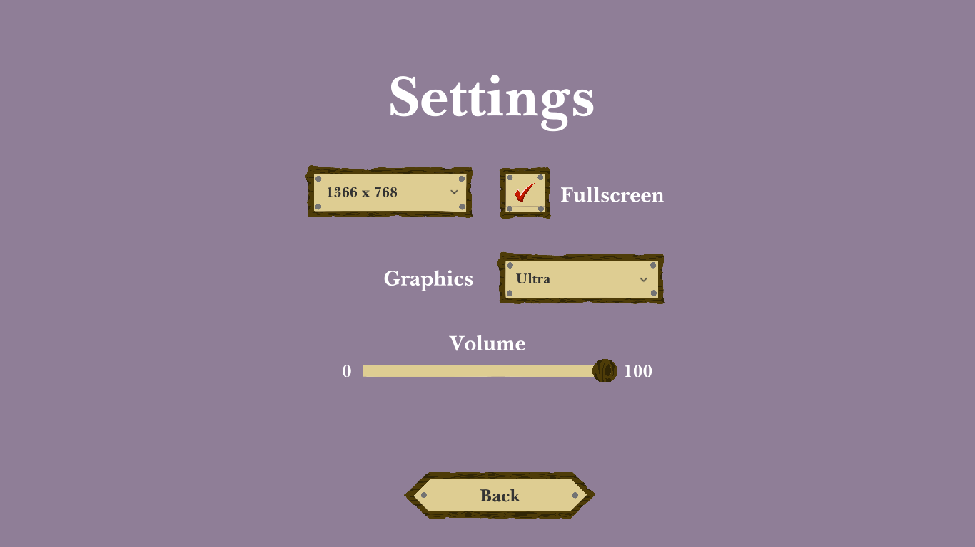

Image 13 - Settings Menu Screen.

In the main menu, pause menu and settings menu the UI used is very simplistic, all following the same aesthetic, using dark and light browns reminiscent of wood. The options available in the main menu are to create a new game, resume a previous game saved, change the settings and exit the game. These last 2, as well as returning to the main menu are the options available in the pause menu.

The settings allow the player to change the screen resolution, change between fullscreen and windowed mode, change the graphics quality and the volume of the game sounds.

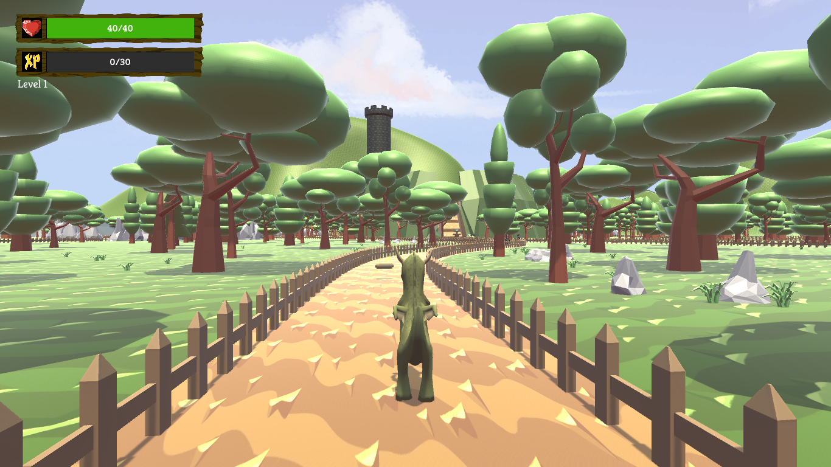

Image 14 - World View.

In the open world the user interface used is very intuitive. We can see in the top left corner represented through bars the health and experience left to the next level, as well as the level the player has right currently.

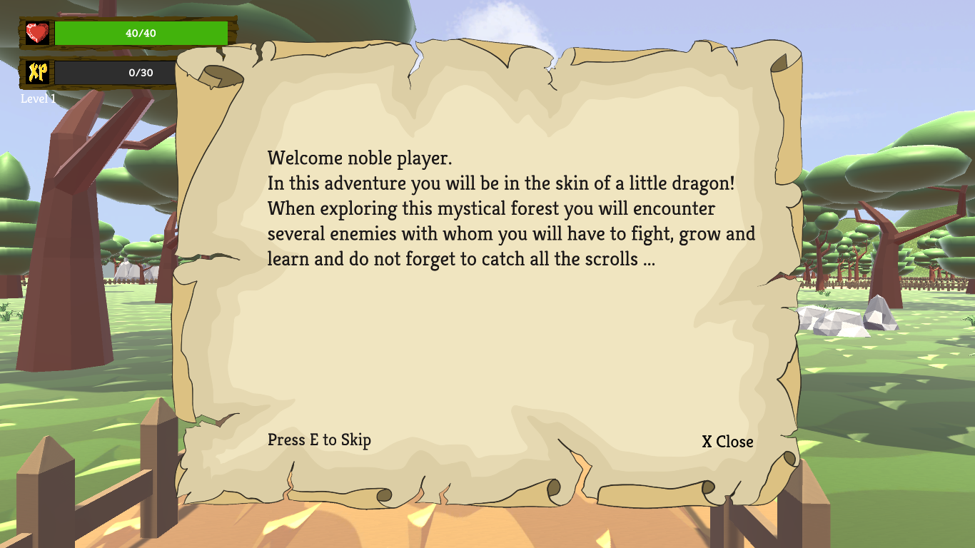

Image 15 - Scroll User Interface.

Among the items present in the open world there are scrolls that give the player some insight of the story, what happened before and the motivation for the little dragon to fight the evil prince. When a scroll is picked up, a window opens and a text is written on the screen sequentially, allowing the player to skip the writing, showing the whole text at once, through the information present on the bottom of the window. It also has a button to close the window at the bottom right corner.

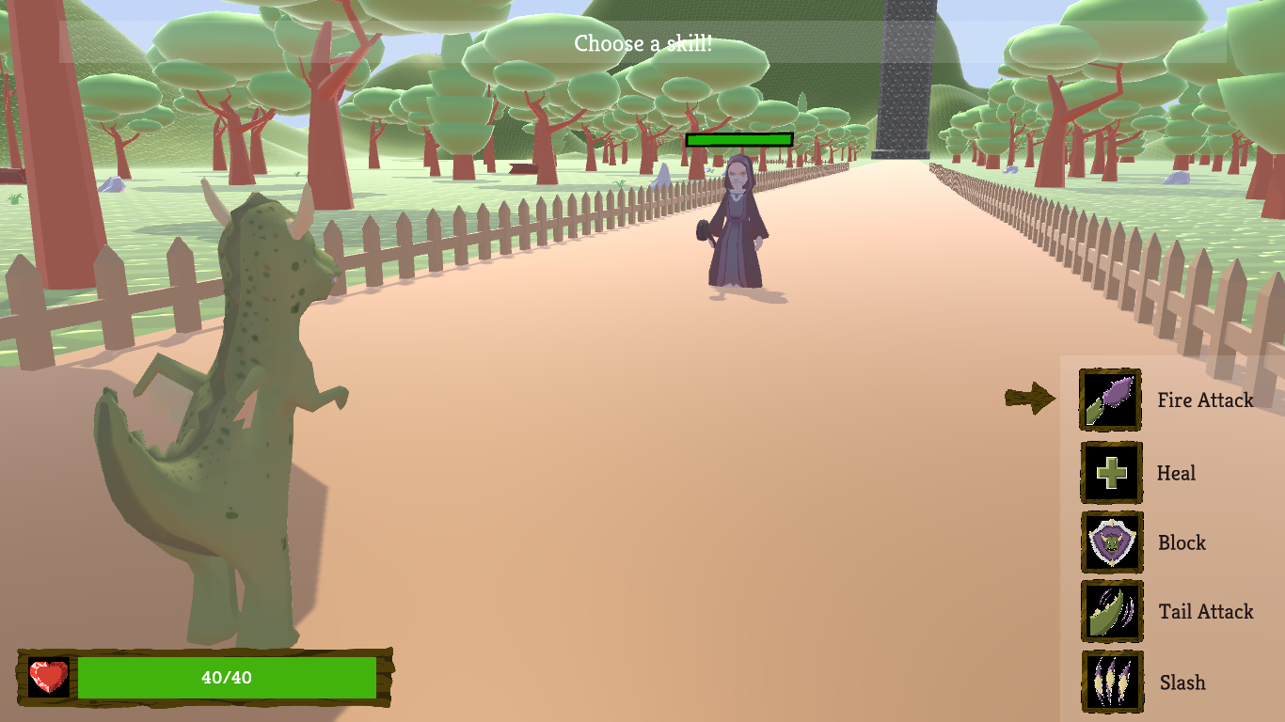

Image 16 - Battle Scene with Skill indicator.

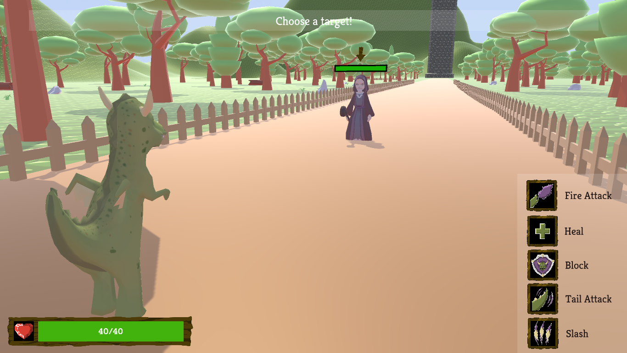

Image 17 - Battle Screen with enemy indicator.

In the battle the UI is intuitive as well. There is an arrow which indicates what to select next and an information window where it clarifies what is currently happening at the top of the screen. The information changes automatically when something is selected or an action is occurring.

On the bottom right corner there is a list of all the skills the dragon has. The arrow points to the one that is currently selected and can be moved with the up and down arrow keys. Some of the skills have a cooldown associated and can’t be selected when on cooldown. That is represented with a dark overlay on top of the skill’s image and a number with the number of turns left until it can be used again.

On the bottom left corner is the player’s health bar.

On top of each enemy there is a bar that indicates its health. An arrow appears on top of the enemies when the player is selecting which one to attack. It moves through the enemies using the left and right arrow keys.

When the battle ends, a text with the result is shown on the middle of the screen.

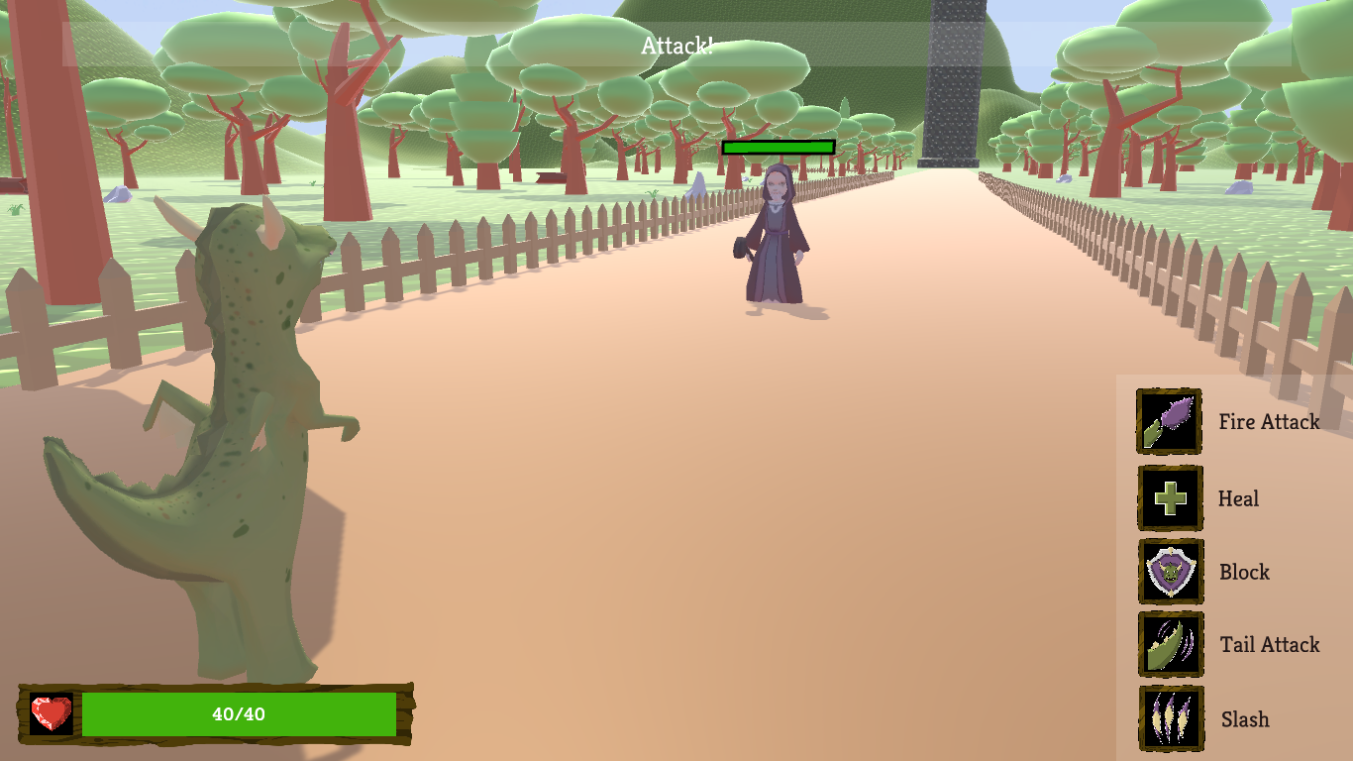

Image 18 - Battle Screen indicating the player is attacking on the top screen tooltip.

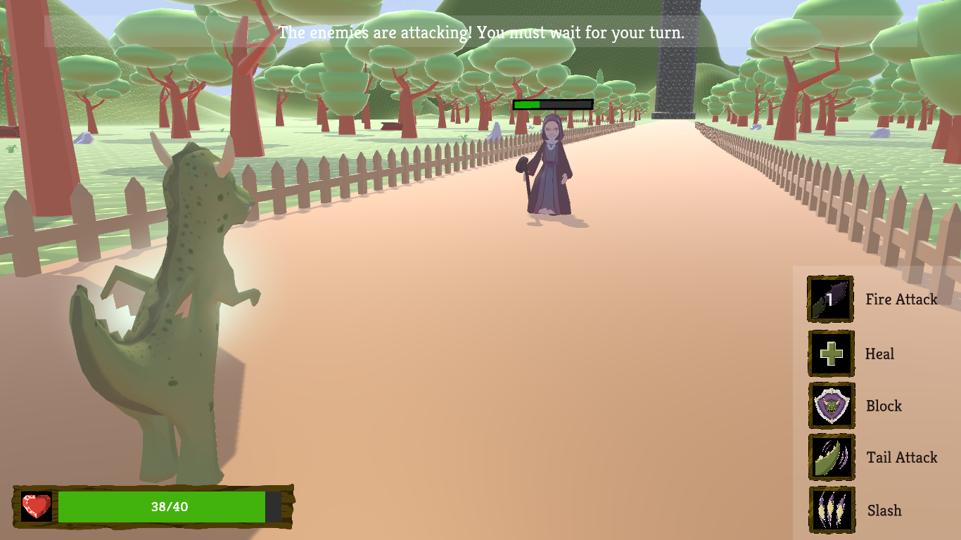

Image 19 - Battle Screen indicating the enemies are having their turn on the top screen tooltip.

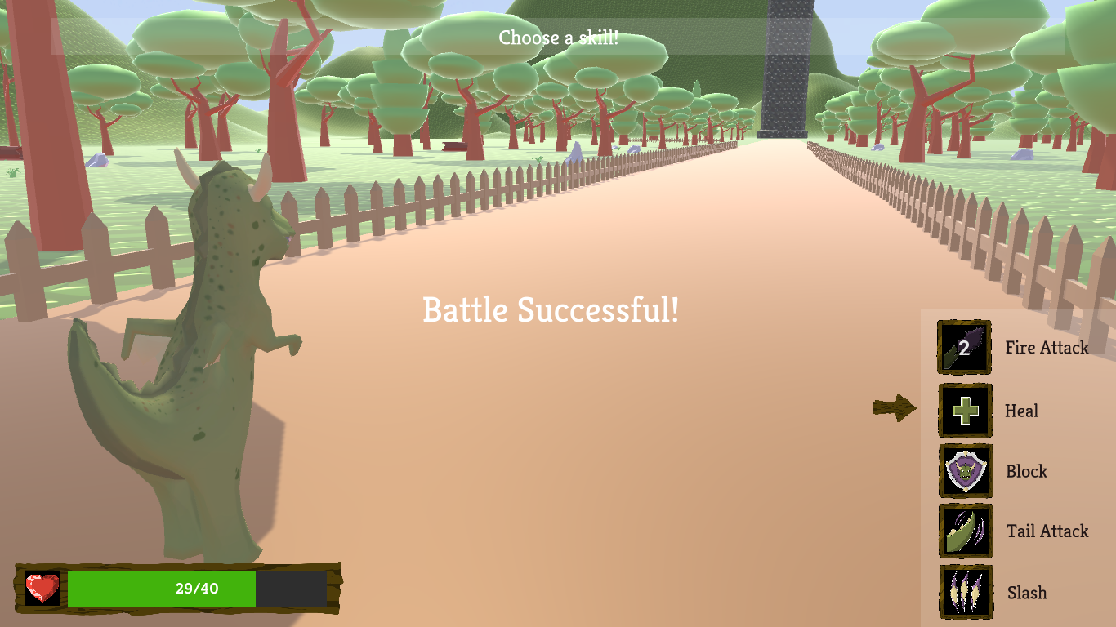

Image 20 - Battle Screen showing the victory text.

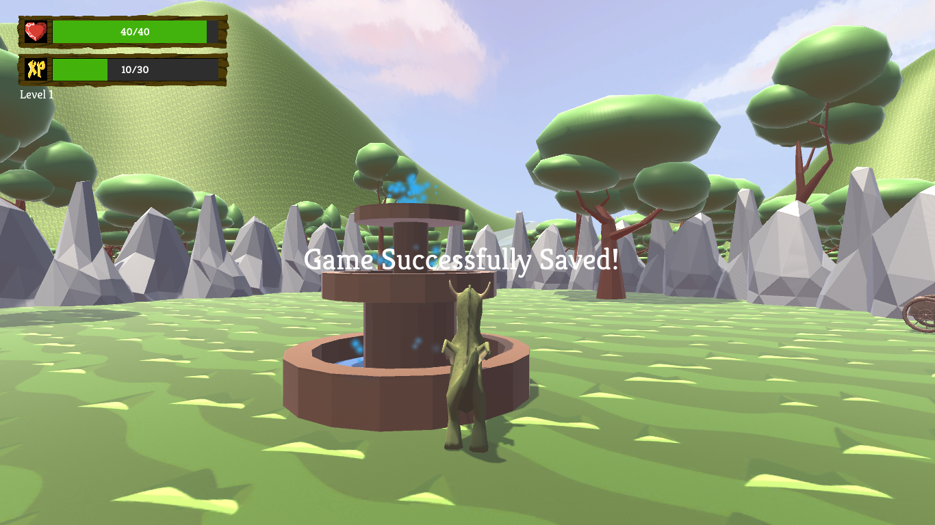

Image 21 - World View showing the game saved text.

The fountains are another item that can be found on the open world. When one is touched by the player and it hasn’t been used yet, a text that informs the player that the game has been saved shows up on the middle of the screen for 3 seconds and then fades out.

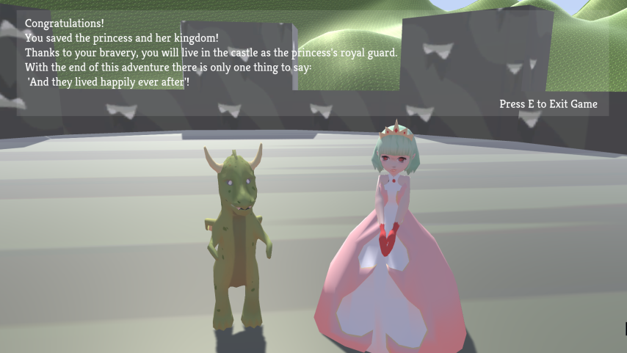

Image 22 - End Game screen.

# 

# Concept Art

The characters models feature a stylized look in order to make it easier to convey personality through the character models.

Despite the simplified anatomy, the head and hands are enlarged compared to a normal human to display facial features and body language more prominently.

Some characters also display other enlarged body or clothing parts to improve their silhouette, such as shoulders or skirts.

This enhances the player's perception on the character's alignment, aggressiveness towards the main character and the need to fight or protect said character at first glance.

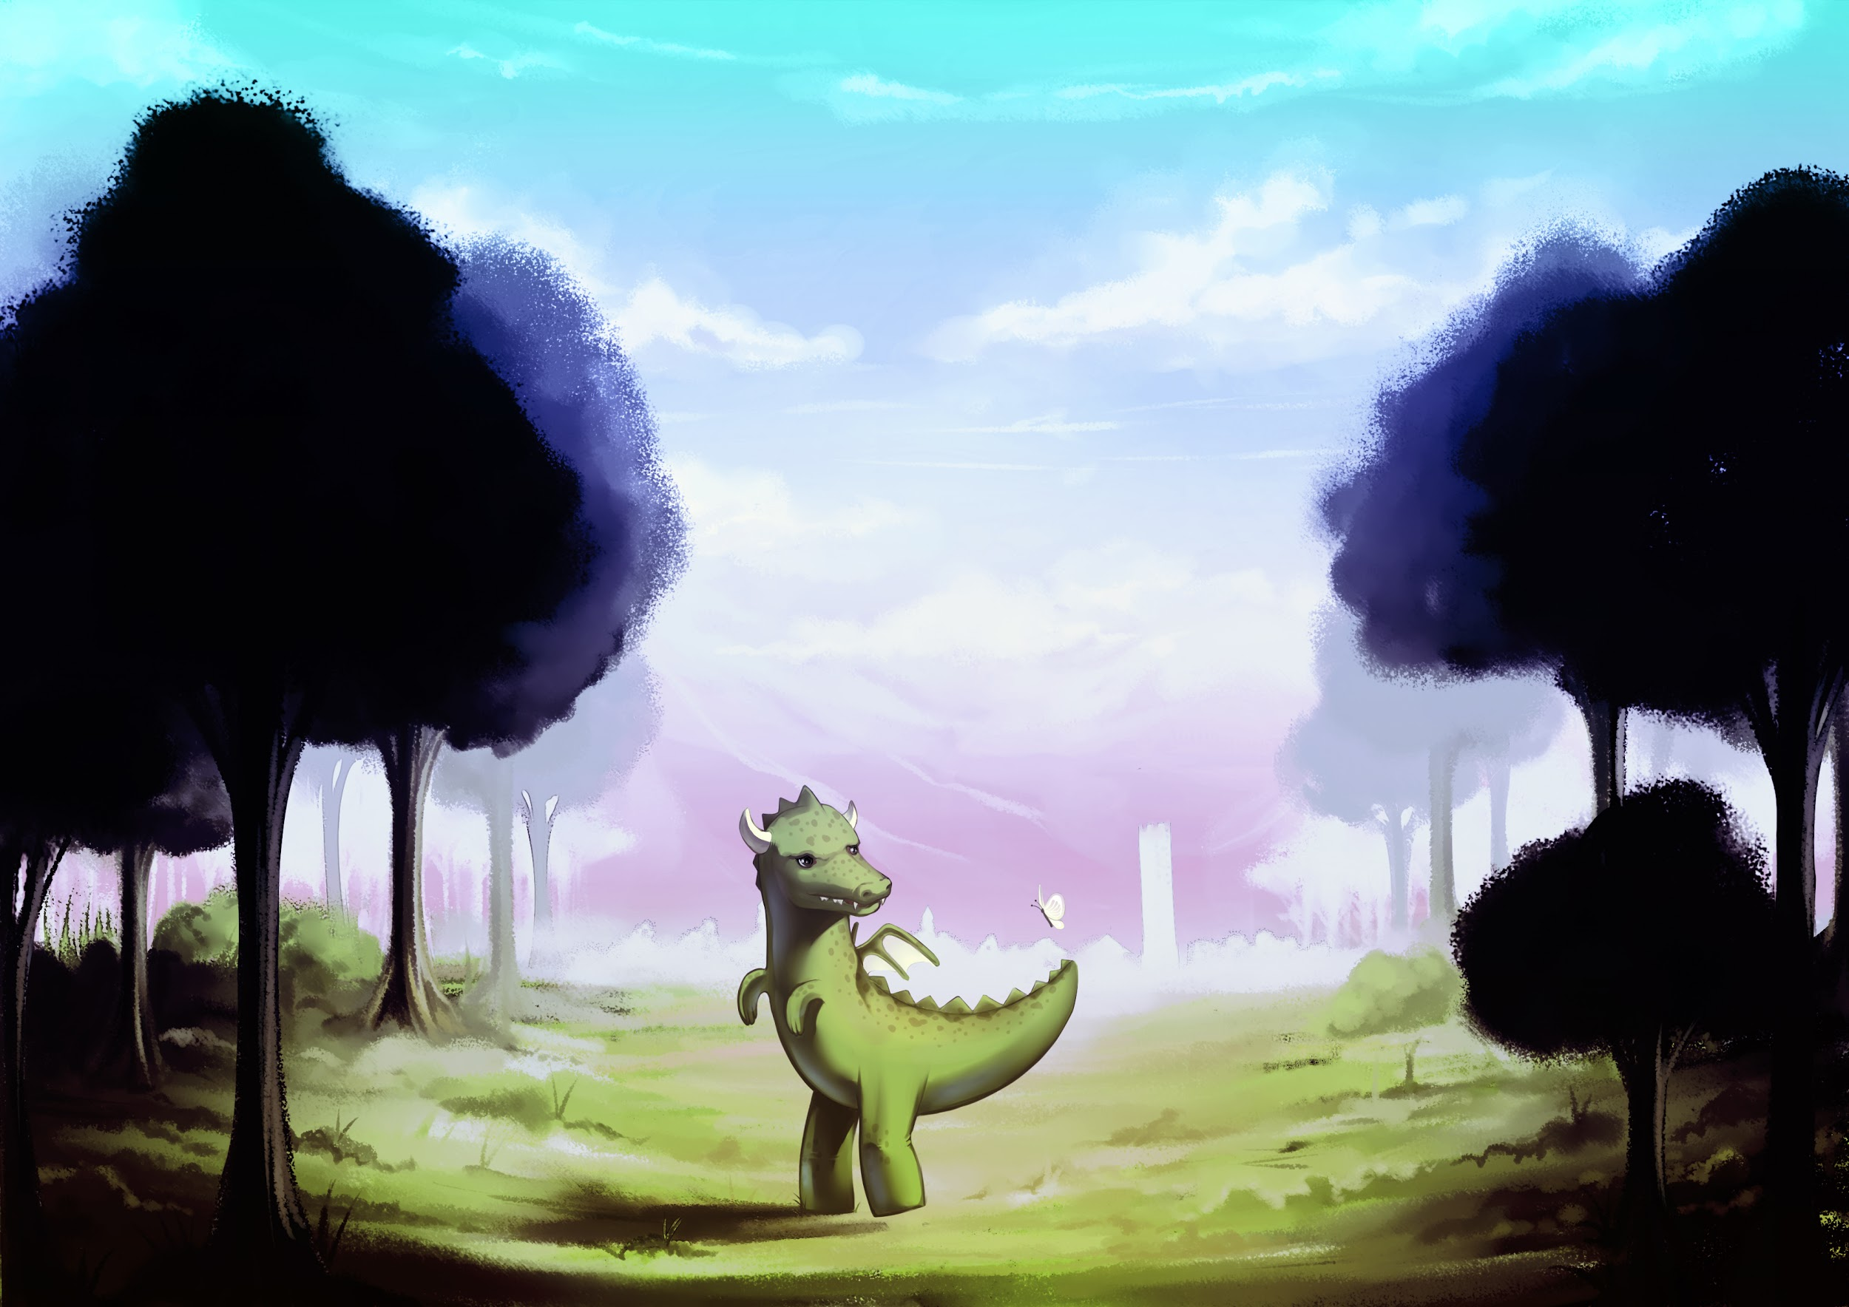

Image 23 - Dragon and environment concept art.

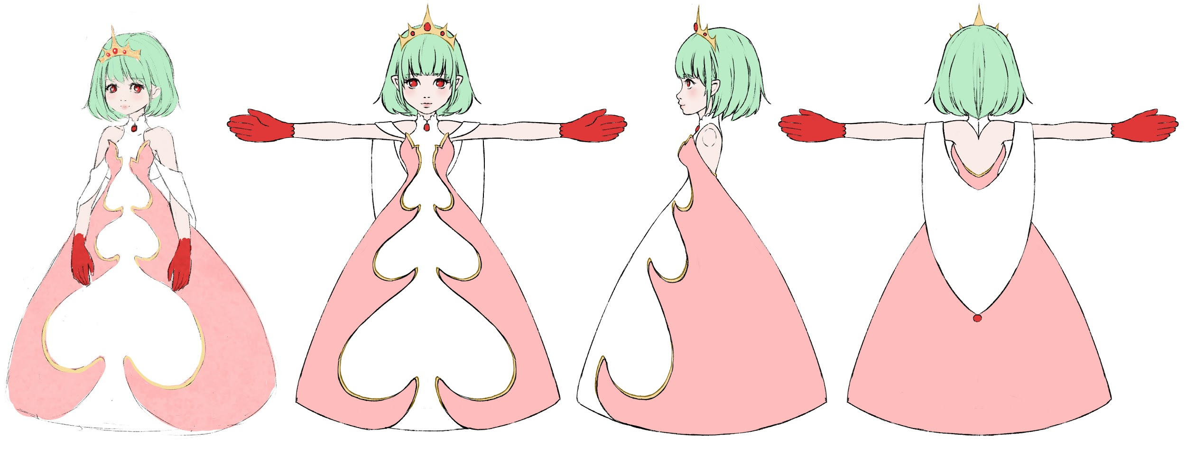

Image 24 - Princess concept art.

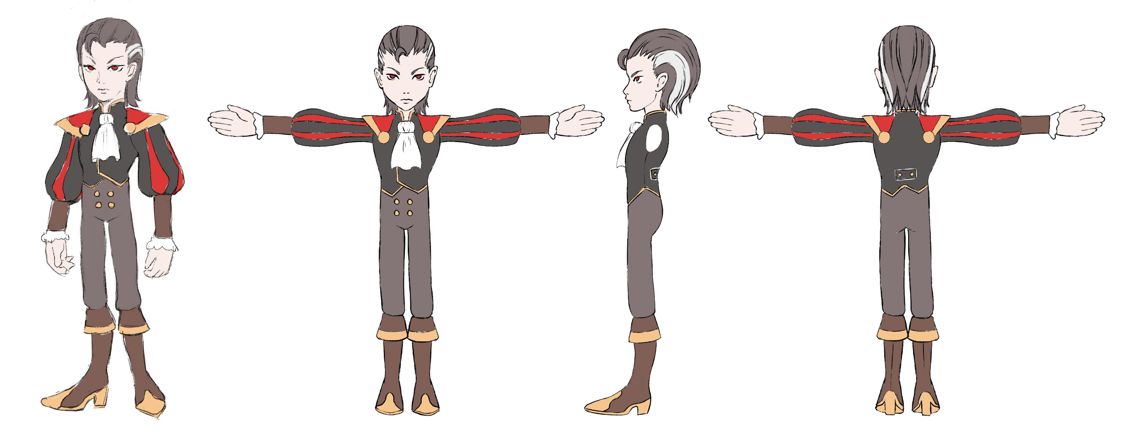

Image 25 - Prince concept art.

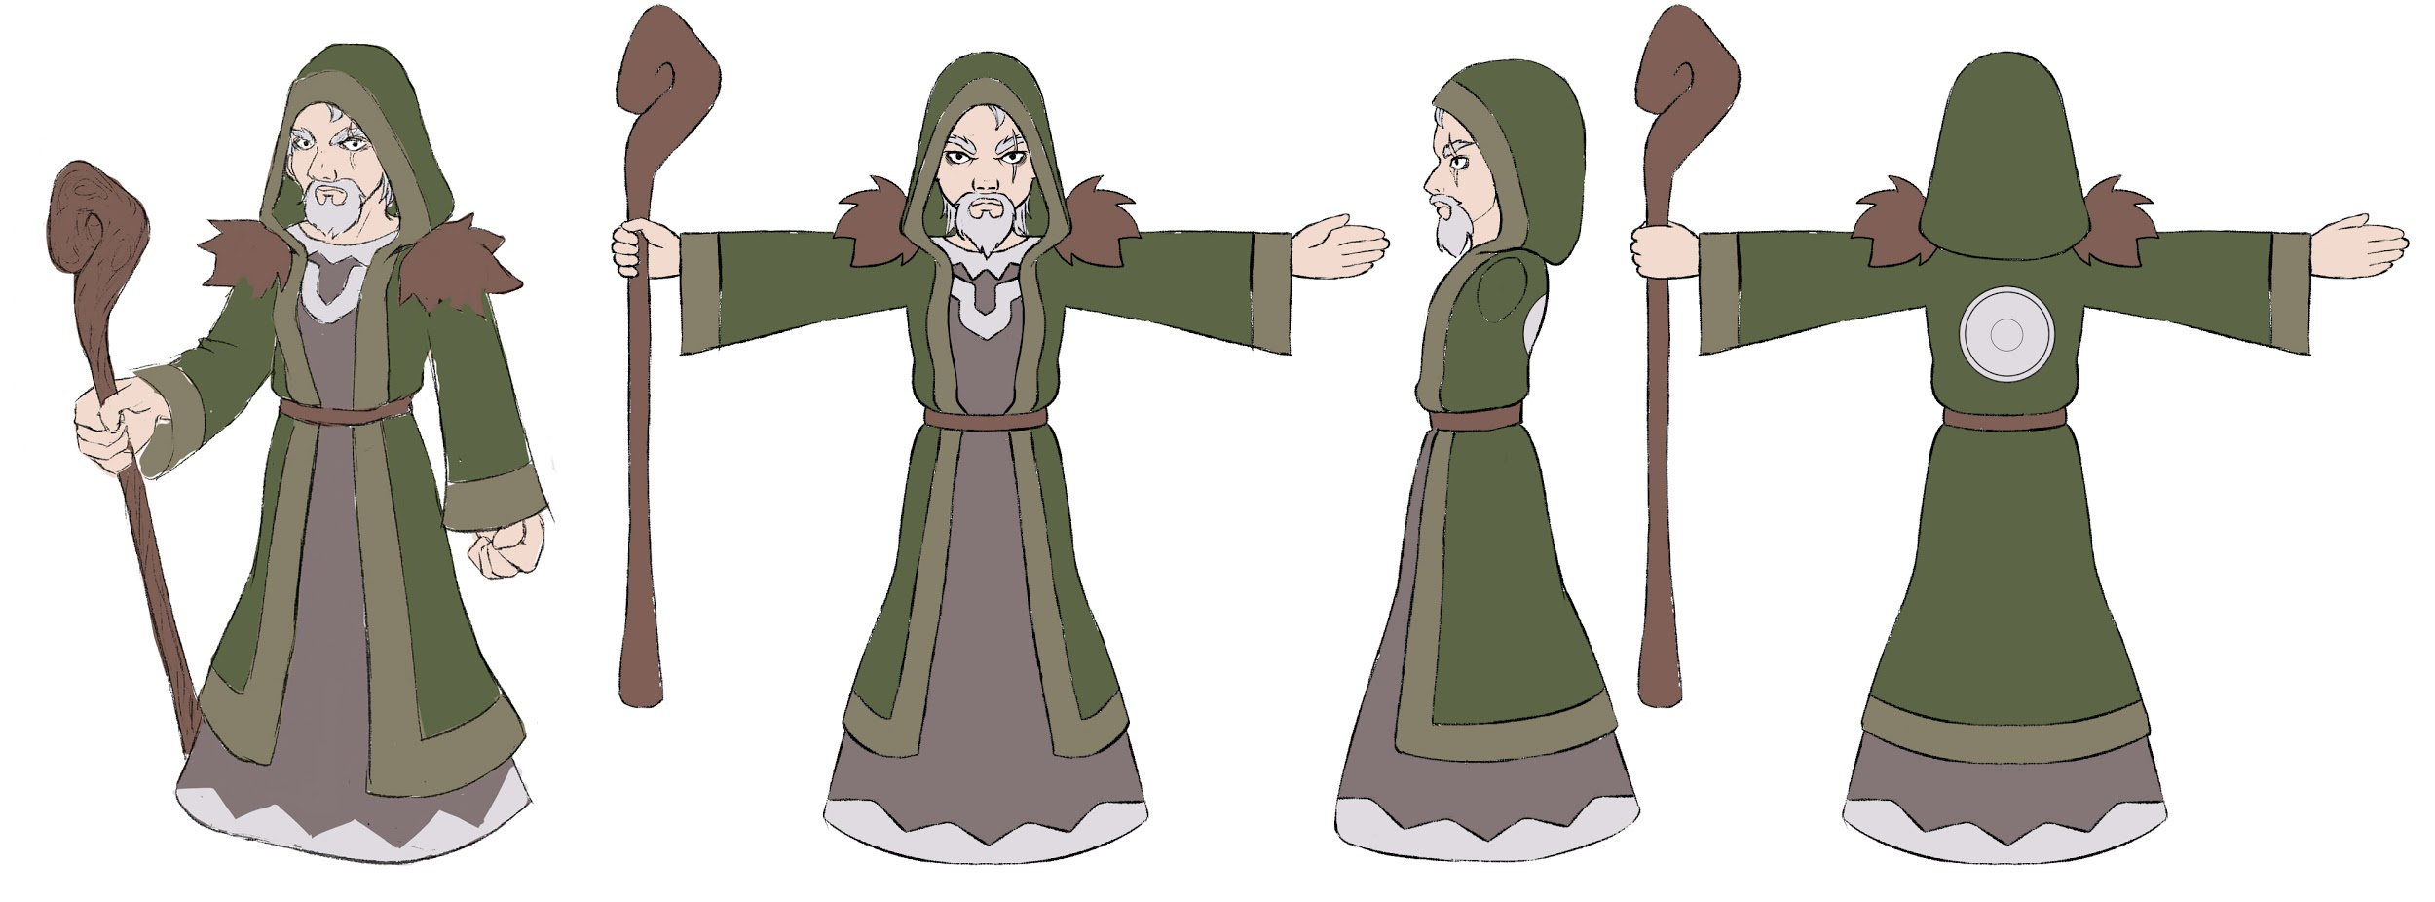

Image 26 - Mage concept art.

# 

# Sound

The game features adaptive soundtracks to the environments and game zones to reinforce gameplay with seamless transitions between the different themes, as well as realistic soundscapes that acompain the soundtrack music.

The game soundtrack is orchestral/fantasy themed, having a main theme, present in the main menu, exploration themes for the open world, being calm and relaxing indicating that the dragon is free to explore the world at his own pace, and combat themes for the battles (being different when the battle is against NPCs or against the final boss) that are aggressive and fast paced indicating danger towards the player.

All the characters present in the game have sound effects associated with the different actions they can do, as well as the items present in the open world, for example when picking a scroll or the sound characteristic of the fountains.

There is also sound effects for the User Interface present in the menus.

# Technologies

The development team used Unity as the game engine, Git for version control, Blender for 3D modelling, Adobe Photoshop for textures and sprites, Adobe Illustrator for icons, Fruity Loops for the arrangement of the score and FMOD for sound design.

# Video

[**https://vimeo.com/276323608**](https://vimeo.com/276323608)

# 